Pranav Pradeep Rao

prao43

November 5th 2018

**Project 3: Manual Strategy**

**Introduction:**

The aim of this project is to develop a trading strategy by determining valuable indicators based on Technical Analysis to trade stocks and increase the portfolio value. In this project a single stock is considered with the ticker symbol “JPM”. The in-sample period is tested between Jan 1st 2008 to Dec 31st 2009, while the out-sample period is tested against Jan 1st 2010 to Dec 31st 2011. The initial sum of $100,000 is invested and the only positions allowed are 1000 shares short and 1000 shares long and 0 shares.

**Technical Indicators:**

Technical Indicators are based on historical data and mathematically derived from stock price and volume information. They are used to predict the future price so as to enable profitable trading. The three main indicators used are Simple Moving Average (SMA), Momentum and Bollinger Bands with percentages. For all graphs a window of 20 days was used and prices for ‘JPM’ have been normalized.

*Simple Moving Average (SMA)*

SMA is the rolling mean of the price of the stock that has an “N” days window to calculate over. SMA can tell you the average within the window and whether the price is undervalued or valued at a given time. It naturally adjusts to more permanent changes allowing traders to profit off short volatility. In Figure 1 the normalized price of stock ‘JPM’ is shown, the SMA shows the trailing average is between 0.5 and 1.25 of the normalized value. The Price/SMA graph shows the fluctuation in price compared to the moving average this helps to further display potential opportunities. For example, if the Price/SMA is greater than 1 then the stock should be SOLD and if it is less than 1 it should be purchased.

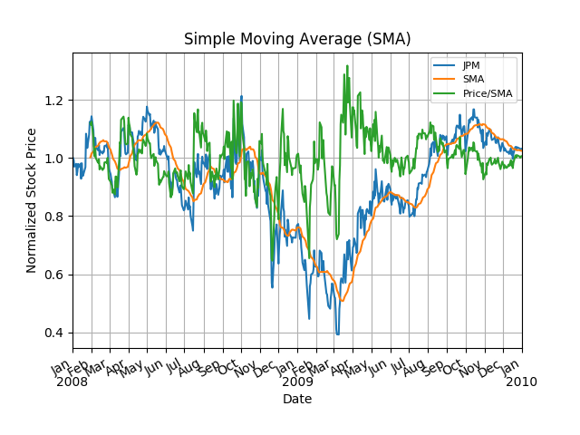

*Figure 1: SMA In-sample results*

*Momentum*

Momentum is calculated by the amount the price has changed from some “N” day ago. This is indicator is displayed in Figure 2. It tends to fall between 0.5 and -0.5. If there is no change in price then the momentum will be zero. The momentum saw significant changes between April and May of 2009. This means that it could be used to indicate a BUY if the momentum drops and a SELL if a momentum rises. The stock values of ‘JPM’ have been normalized here starting at 1.0.

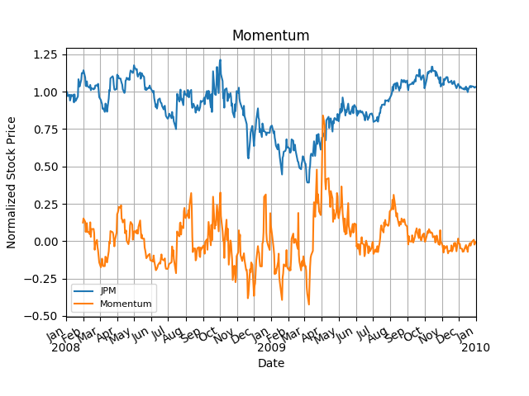

*Figure 2: Momentum In-sample results*

*Bollinger Bands and Bollinger Bands Percent*

Bollinger Bands were invented by John Bollinger in the 1980s. The bands are created by adding and subtracting the standard deviation from the SMA price value. This gives us the upper and lower bounds of the band. These bands indicate when a stock price has deviated significantly from the expected behavior and will be correcting. This is an opportunity to generate a profit from a price correction. This indicator is rendered in Figure 3. The fall in stock price from November 2008 to January 2009 was a BUY opportunity, while the rise in price from September to October 2008 was a SELL opportunity. The gray area represents the normal range for the price to remain. If the price moves to a new value the SMA will increase and the Bollinger values will represent this adjustment giving us a holistic view of the stock price at any given time.

The Bollinger Bands Percent is an extended indicator from Bollinger Bands to display the proximity of stock price exceeding the bands. This helps to more accurately capture a BUY and SELL point. For example, in Figure 4 the percentage value of 1 implies the price is at the upper Bollinger value while a 0 implies the price is at the lower Bollinger value. The gray area represents the percentage range for the price to fluctuate within the Bollinger bands. The closer the value comes to these then we should SELL and BUY respectively. During testing it was determined that a good sell indication was when the price was close to the 95th percentile (0.95) and a sell if it was close to the 5th percentile (0.05).

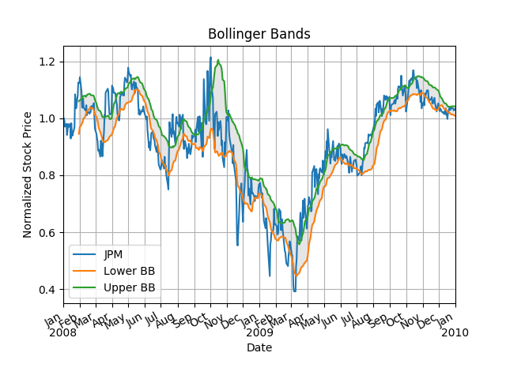

*Figure 3: Bollinger Bands In-sample results*

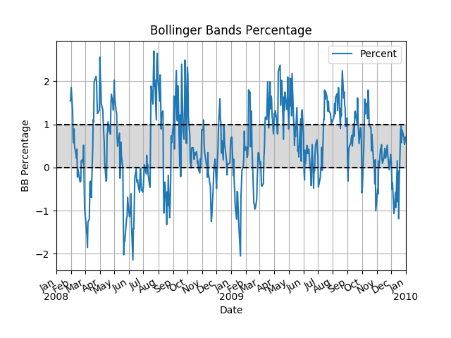

*Figure 4: Bollinger Bands Percentage In-sample results*

**Theoretically Optimal Strategy:**

In this stage we attempted to represent the result when the best series of trades are entered. This was done by using in-sample data to determine what is the maximum profitability that can be achieved. This was done by looking at the future date price. If the future price fell we would SHORT the stock and if the price rose we would LONG the stock. The results are displayed in Figure 5 and Table 1 for In-Sample. This represents the upper threshold result of our strategy. A +1000 indicates a BUY of shares, a -1000 indicates a SELL of 1000 shares and a 0.0 means HOLD and do nothing. The benchmark normalized value is in **blue**, while the best possible portfolio normalized value is in **black**. The symbol of stock used here was ‘JPM’ and the in-sample data is between January 1st, 2008 to December 31st, 2009. The benchmark is defined as the performance of the portfolio beginning with $100,000 investment and 1000 shares of ‘JPM’ on HOLD for the same period. Here a $0.00 commission and 0.0 impact on stock was used in calculations.

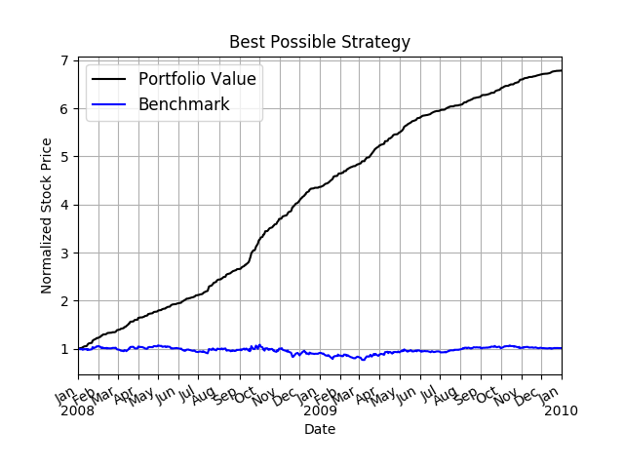

*Figure 5: Best Possible Strategy In-sample results*

|  |  |  |
| --- | --- | --- |
|  | Benchmark | Portfolio Value |
| Sharpie Ratio | 0.156918406424 | 13.3227698482 |
| Cumulative Return | 0.0123 | 5.7861 |
| St. Dev of Daily Return | 0.0170043662712 | 0.00454782319791 |
| Average of Daily Return | 0.000168086978191 | 0.00381678615086 |

*Table 1: Best Possible Strategy In-sample results*

**Manual Rule-Based Trader:**

In the final solution I used two of the above indicators Bollinger Bands Percent (BBP) and Momentum. Momentum was useful in determining when the market is going downward or flattening off. BBP is a momentum oscillator and can be used to see when to go long or short. Both of these were able to anticipate the change in the price of stock correctly. The logic for strategy can be broken down as follows:

1. If the Momentum is less than -0.01 and the Bollinger Bands Percent is less than 0.05 and the current holdings is less than 1000; then we should BUY. If the total holdings are 0 then 1000 shares should be bought. If the total holdings are -1000 as a short then we should buy 2000 shares.
2. If the Momentum is greater than 0.01 and the Bollinger Bands Percent is greater than 0.95 and the current holdings is greater than -1000; then we should SELL. If the total holdings are 0 then 1000 shares should be sold. If the total holdings are 1000 as a short then we should sell 2000 shares.

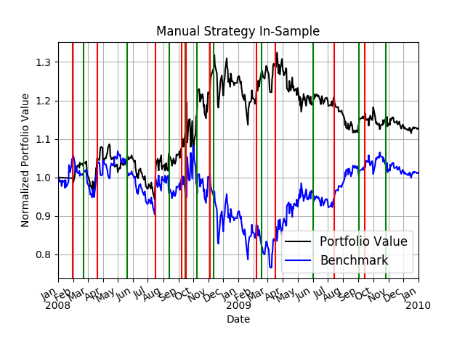

*Figure 6: Manual Strategy In-sample results*

|  |  |  |
| --- | --- | --- |
|  | Benchmark | Portfolio Value |
| Sharpie Ratio | 0.157204964889 | 0.38484979255 |
| Cumulative Return | 0.0123249333401 | 0.127465682835 |
| St. Dev of Daily Return | 0.0170412470682 | 0.013643754089 |
| Average of Daily Return | 0.000168759162146 | 0.000330769052807 |

*Table 2: Manual Strategy In-sample results*

These results for the in-sample are displayed in Figure 6 and the values are rendered in Table 2. The benchmark normalized value is in **blue**, while the best possible portfolio normalized value is in **black**. The vertical green lines indicate a long entry point while a red line indicate a short entry point. The symbol of stock user here was ‘JPM’ and was the in-sample data is between January 1st, 2008 to December 31st, 2009. The benchmark is defined as the performance of the portfolio beginning with $100,000 investment and 1000 shares of ‘JPM’ on HOLD for the same period. Here a $9.95 commission and 0.005 impact on stock was used. The strategy outperforms the benchmark with the in-sample data.

**Comparative Analysis:**

The manual strategy was tested with the out-sample data between January 1st, 2010 to December 31st, 2011. By comparing the Cumulative Returns on the portfolio value for in sample shows it performed fairly well. The Cumulative Returns for in-sample is 0.127465682835 while for out-sample is 0.0203675265689. The out of sample did not perform as well but was positive proving it generated profitable results and the portfolio value increased. Both strategies do not do nearly as well as the ideal best possible strategy. Predicting the future with a 100% accuracy is challenging and would require significantly more indicators and test data. In addition, there were no commission or impact on the theoretical strategy calculations.

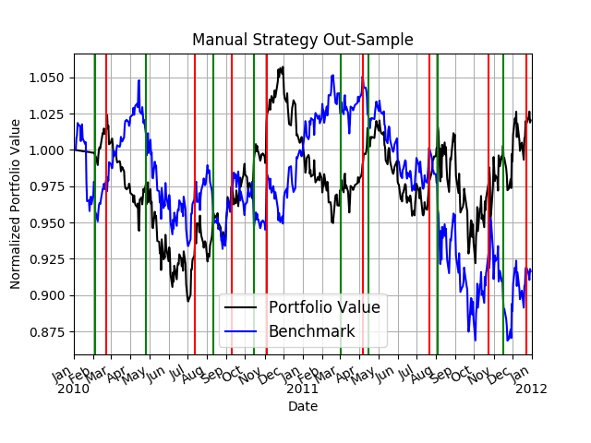

*Figure 7: Manual Strategy Out-sample results*

|  |  |  |
| --- | --- | --- |
|  | Benchmark | Portfolio Value |
| Sharpie Ratio | -0.25665656052 | 0.142974718408 |
| Cumulative Return | -0.0835791100328 | 0.0203675265689 |
| St. Dev of Daily Return | 0.00850015832233 | 0.00795917910083 |
| Average of Daily Return | -0.000137429230389 | 7.16848295568e-05 |

*Table 3: Manual Strategy Out-sample results*

The results for the out-sample are displayed in Figure 7 and values renders in Table 3. The benchmark normalized value is in **blue**, while the best possible portfolio normalized value is in **black**. The vertical green lines indicate a long entry point while a red line indicate a short entry point. Overall the implementation strategy does work and beats the benchmark but there is room for improvement and more indicators can be used to generate a better predictor of trades.